|  |  |
| --- | --- |
| Nikon Z 24-70mm f/2.8 S lens  Ống kính Nikon Z 24-70mm f/2.8 S  nikon-z-24-70mm-f-2-8-s nikon-z-24-70mm-f-2-8-s-1 nikon-z-24-70mm-f-2-8-s-6 nikon-z-24-70mm-f-2-8-s-2 | **Featured information:**  Two ED lenses and four aspherical lenses  ARNEO and Nano Crystal coating  Z mount lens / FX format  Aperture range: f/2.8 to f/22  Price : $ 1900  **Specifications:**  Focal distance  24 - 70mm  Largest Aperture  f/2.8  Smallest Aperture  f/22  Lens Mount  Nikon Z  Lens Format  Full-Frame  View  84 ° - 34 °20'  Minimum Focus Distance  38 cm  Magnification  0.22x  Optical Components  17 lenses in 15 groups  Number of Mouth Blades  9  Focus Type  Auto focus  Anti-Vibration |

**Overview:**

The Nikon Z 24-70mm f2.8 S Lens is a 24-70mm standard zoom lens that helps you capture every creative perspective. With a constant maximum aperture of f/2.8, the lens is capable of capturing clear images in a variety of lighting conditions, even in low light. The special optical design helps reduce aberrations and spherical aberrations, providing accurate, clear and sharp image quality. The lens is small in size and light in weight, suitable for photographers who have to move a lot.

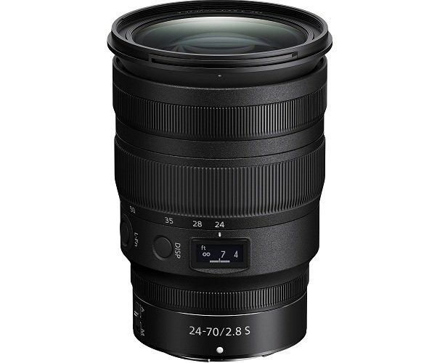

This standard zoom lens is designed specifically for Nikon's FX-format Z-mount mirrorless cameras. Fixed f/2.8 lens aperture delivers consistent performance throughout the zoom range. Also with this aperture, the lens supports taking sharp and clear photos even in poor lighting conditions. At the same time, it allows you to take beautiful bokeh photos with impressive bokeh or background blur effects.

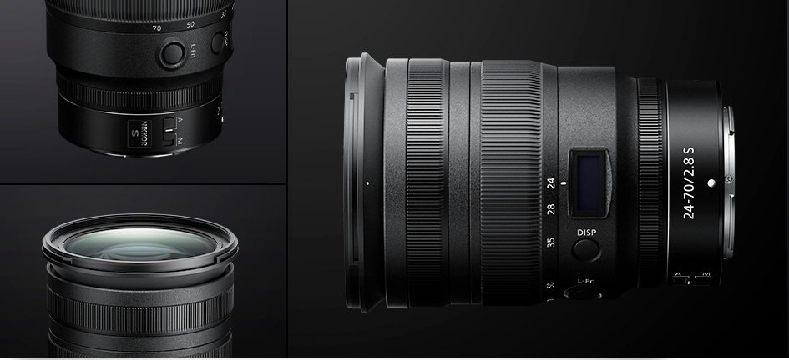

Designed to be dust and moisture resistant, the lens can be carried and used in many weather conditions, even the harshest. Ensuring photographers always get quality photos and don't miss any moments.

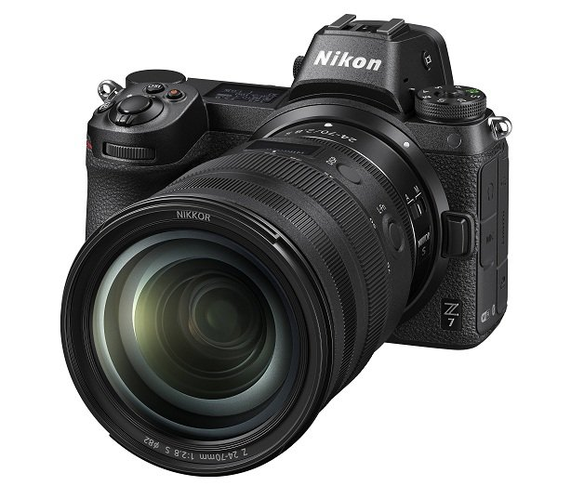

Nikon Z 24-70mm F2.8 S with an aperture diaphragm structure consisting of nine rounded blades provides comfortable focusing quality, creating a shallow depth of field, providing photos with impressive bokeh effects.